Institutional Affiliation
Students Name
Date

Medtronic PLC Case Study
This case study aims to determine the problem faced by Medtronic plc regarding its business methodology and how it managed to overcome these challenges. Medtronic PLC strategized in the production of medical equipment's which, of course, greatly benefitted the company. However, the production and sale of medical devices limited the company's net income as much concentration was on only one item: production and sales. As much as this was a good idea, the company did not benefit from their innovations; for example, they could not have treated patients using their devices since they focused on marketing. In the modern economy, it is more beneficial for a company to diversify in several businesses to maximize profits and minimize risks associated with production. The outbreak of different new traits of diseases such as the Covid-19 requires new techniques and approaches, creating the need for new strategies. Furthermore, diversity can help a business safeguard its investments if it is not in the accumulation period of life. Therefore, a business needs to think towards maximizing income and finding an additional method of earning profits.
Earl Bakken and Palmer Hermundslie started Medtronic PLC, a medical technology firm, in 1947. Medtronic is particularly known for its artificial heart devices and insulin pumps. The companies headquarter are located in Dublin, Ireland. It began as a medical devices repair company and has since expanded to become the largest global medical equipment manufacturer (El-Chami et al., 2018). The company's first product was a battery-operated exterior artificial pacemaker, which was revolutionary at the time. Medtronic started to sell these and other medical equipment in the 1950s. In the 1970s, it built its operations center in Fridley, Minnesota. Medtronic has made several investments to increase its product line and competence. In 2014, Medtronic company purchased Covidien, the world's largest medical device, to provide a comprehensive and deep healthcare offering and secure global expansion. Since then, Medtronic has continued to grow via acquiring companies to meet its growth and improvement objectives.
Medtronic PLC acquired Cardiocom LLC, a privately held disease-control and patient-care company, in a move that the company expects would capitalize on rising healthcare expenditure worries and gain from it, for $200 million. The acquisition, according to the corporation, was part of a larger plan for the future. Some experts, however, fear that this acquisition could signal a tough moment for the medical device sector, as well as Medtronic's conviction in its core MedTech company. Nevertheless, the acquisition was utilized back in 2013, and since then, it has resulted in great achievement for the company.
Medtronic's acquisition of Cardiocom demonstrates its commitment to go beyond devices and into data. The significance of device firms' continuing expansion and innovation in how they engage with healthcare and offer healthcare is great. Medtronic takes its first move toward developing core services and solutions with Cardiocom, a well-established, profitable, and fast-growing firm. The development of new health requirement policies has created a greater advantage to the Medtronic company since adopting the telehealth system. The focus on remote health's influence on readmissions by Medtronic isn't just healthcare hype. This technique fits with the company's overarching data strategy for determining effectiveness: it's a means to track patients' health and illness progression while gathering data on both. The company has also improved on services provision since it has extended its services to provide healthcare services to patients. Medtronic Labs was founded in 2016 as a social enterprise to improve healthcare access for disadvantaged clients, families, and societies throughout the world. Medtronic Labs creates technology-enabled service delivery solutions that address significant hurdles and healthcare continuum services, therefore reaching many people globally.
The public is indeed aware of the new services offered at Medtronic plc. A great percentage of revenue in the company was received through cardiovascular treatments. The cardiac and vascular group was Medtronic's largest operating segment, with sales of $10.5 billion (Carter, 2018) as illustrated in figure 1below.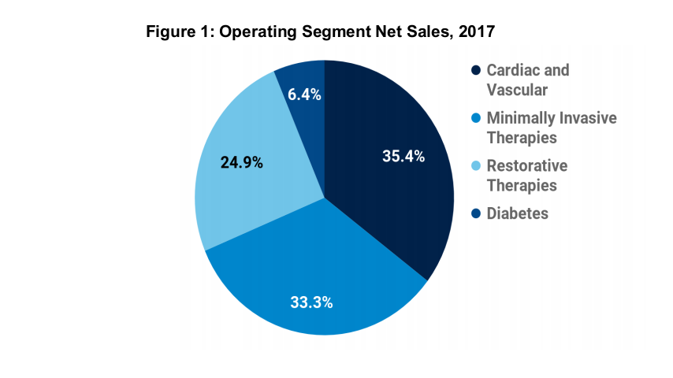 It is made up of goods used to diagnose, treat, and manage cardiac issues, including the use of Cardiocom in the services. The services offered at Medtronic are available online, from their website to social media platforms such as Instagram, Facebook, and Twitter. More information about Medtronic is also available on youtube. Medtronic plc has not changed in its method but has added additional profitability and customer satisfaction (Libbra, 2017). They have incorporated treatment to the earlier services they were providing. The acquisition of the Cardiocom company was not a new method since the company started diversifying during the early stages of its development. For instance, the company started selling products from other companies, such as the Sanborn Company of Boston.
I would recommend that the company continue focusing on providing quality-based medical care to their patients and improving their medical facilities globally. Doing this will enable brand growth and increased recommendations from satisfied consumers.
In conclusion, this analysis is very significant in the modern business world, especially developing enterprises. Firstly, it advocates for consistency in business which is essential for a new business organization. Secondly, it highlights how entrepreneurs can expand their business to maximize profitability and customer satisfaction. The expansion and client satisfaction strategies diversify into different products and services, adopting modern business methods and partnerships. It was through collaboration that Medtronic came into existence. From this analysis, individuals learn that people with different skills can collaborate and use their skills effectively for more significant achievements. We also know to have different thoughts; the healthcare equipment industry, like other large businesses, encourages us to think diversely: courageously, passionately, and creatively. Finally, companies realize that they must always have a mission. Medtronic's mission has served the globe well for nearly half a century, through both good and bad times. Every firm should have a mission statement to drive its goals and remind them why they exist and who they serve.

References
Carter, J. (2018). A Strategic Audit of Medtronic PLC.
El-Chami, M. F., Al-Samadi, F., Clementy, N., Garg, C., Martinez-Sande, J. L., Piccini, J. P., ... & Roberts, P. R. (2018). Updated performance of the Micra transcatheter pacemaker in the real-world setting: a comparison to the investigational study and a transvenous historical control. Heart Rhythm, 15(12), 1800-1807.
Libbra, J. (2017). Return Behaviors of US-Based Multinational Companies. IMCA Investments & Wealth Monitor, Forthcoming.

